**EMSE 6099 Final Report**

Group 1

***A Profitability and Sustainability Analysis of an Ideal Hard Seltzer Product***

By: Christian Lane, Javier Langarica, Myrto Kampouris, Vysaaly Sivakumaar

Spring 2022

THE GEORGE WASHINGTON UNIVERSITY

TABLE OF CONTENTS

**Introduction** **2**

**Literature Review** **2**

**Approach** **6**

**Results** **10**

Phase 1: Year Zero 10

Production Costs 10

CO2 Emissions from Production 11

Projected Market Performance by Alternative 12

Phase 2: Forecasting 13

Forecasted Market and Competitor Growth 13

Forecasted Market Shares and Revenues 13

Forecasted Production Costs 14

Forecasted CO2 Emissions from Production 15

Gross Profit Margin (GPM) 16

Net Present Value of Gross Profit Margin by Alternative 17

Multi-Attribute Utility Model and Efficiency Frontier Plot 18

**Discussion** **20**

Implications of Findings, Limitations and Future Research 20

Investor Relations 21

**Conclusion** **22**

**References** **23**

**Appendix** **25**

# 

# **Introduction**

This project presented the opportunity to study the alcoholic seltzer market and the viability of introducing a new seltzer product into the current market. A hard seltzer is a popular alcoholic beverage combining alcohol with flavored carbonated water.[1](https://usualwines.com/blogs/knowledge-base/what-is-hard-seltzer) It is characteristically low in alcohol, sugar, and calories compared to other alcoholic beverages. The alcoholic seltzer market is a booming industry, growing annually by 60% in 2021 to $8.8 billion, and expected to grow at a compound annual growth rate of 21.7% through 2030[2](https://www.grandviewresearch.com/industry-analysis/hard-seltzer-market). Hard seltzers have recently become a trending product, leading to the creation of new brands and the expansion of existing brands into the hard seltzer industry to meet this new demand. Current competitors have created hard seltzer products with various combinations of product attributes, such as price, calories, vitamin presence, sugar content, alcohol content, and packaging material. All hard seltzers are currently packaged in aluminum cans and there has yet to be a competitor to introduce a packaging alternative.

The objective of this project is to create a profitable hard seltzer whose production process considers the environmental impact of its primary packaging materials. To address this, we first modeled and assessed the profitability of introducing a new hard seltzer in the market based on consumer preferences and the production cost estimates of each potential product attribute. Second, we analyzed the difference in environmental impact between aluminum cans and glass bottle packaging, and their effect on production costs. We then forecasted the hard seltzer market from 2021-2028, and finally, created a multi-attribute utility model that helps determine which hard seltzer alternative balances desired levels of profitability and sustainability.

# **Literature Review**

In a previous course, we surveyed the impact that the following key product attributes have on the hard seltzer consumer: price, packaging material, calories per unit, vitamin presence, sugar content, and alcohol content. The survey was coded in R Studio and run through Formr, an online platform, and its results were analyzed using R code. Having assessed which combination of product attributes is most preferred in the hard seltzer market, we discovered that maintaining a low, competitive price while also prioritizing the production of a high alcohol content, low-calorie hard seltzer, yields the highest market share.[3](https://madd.seas.gwu.edu/showcase/2021-Fall/seltzer.html) Additionally, a hard seltzer product with vitamins and low-sugar content, packaged in a glass bottle, would capture additional market share. The results obtained from this market research had shortcomings, such as a profitability analysis of this ideal product and the environmental impact of its per-unit packaging. The previously performed market research project spurred the questions we are attempting to solve accompanied by this subsequent project. This project serves to study the hard seltzer market growth projections over an eight-year time period, known consumer preferences of product attributes, and the cost of producing these products.

From the consumer willingness to pay survey data and market share simulation model in R code from the previous seltzer marketing analytics project, we first collected the price, calories, alcohol content (%ABV), sugar (grams), vitamin presence, and packaging material data of the top 30 competing 12-pack hard seltzer products as listed on drizly.com,[4](https://drizly.com) an established online alcoholic beverage marketplace. When searching what current hard seltzer products are currently available in the market, drizly.com provides adequate information about hard seltzer competitors. These competitors drawn from drizly.com were then inputted into a financial forecasting simulation to create a discounted cash flow over a 7-year period. While looking through all the different brands and their hard seltzer products, an important note worth mentioning is that all hard seltzer products are sold in aluminum cans. Not one hard seltzer is packaged in glass bottles. Having noted this significant detail, this project is geared towards exploring whether packaging hard seltzers in glass bottles could add a market edge as well as being profitable and maybe even environmentally friendly.

Another method of collecting pertinent information was through interviews with subject matter experts––individuals working in the alcoholic beverage industry. On February 3, 2022, we held an interview with Larry Trachtenbroit, who has worked in the alcohol industry space for over 10 years. Mr. Trachtenbroit launched his own product called the “Alc-A-Chino,” which is canned spiked iced coffee. In order to have a market edge, we brought up environmental sustainability and the idea of implementing an eco-label to our product. Eco-label would not have much traction among consumers in Mr. Trachtenbroit’s opinion. In fact, he posed the hypothetical question: *“Would you turn to someone at a party and say ‘Wow, check out this eco-label on my drink?’ I don’t think so.”* When mentioning our glass bottle alternative, he was initially apprehensive because of supply chain issues as glass is easily breakable and heavier to ship, and therefore, can be more expensive. Mr. Trachtenbroit touched on several pros and cons of aluminum cans versus glass bottles. He stated that the ingredients and overall makeup of the liquid product is the cheapest part of the whole operation. His biggest concern about our project overall surrounded the supply chain issues contributing to the hard seltzer industry. It’s one thing to create and launch a new product, but it’s another to distribute it and supply it to consumers.

On March 30, 2022, we held an interview with Madison Reinker, the Sr. Manager of Supply Network Planning in the Supply Chain Optimization at Anheuser-Busch InBev. Ms. Reinker provided meaningful insight into not only the hard seltzer market, but also its shortcomings. Anheuser-Busch is single-handedly responsible for a large portion of the hard seltzer competitors. Some of these competitors include: Michelob Ultra Seltzer, Bud Light Seltzer, Natty Light Seltzer, and BON V!V Seltzers. Ms. Reinker also shared her company’s environmental sustainability segment and their goals: renewable electricity and carbon reduction, water stewardship, smart agriculture, and circular packaging. Regarding the scope of this project, Ms. Reinker shared her understanding of per-unit cost and emission differences between aluminum cans and glass bottles and the processes that contribute to such per-unit metrics. In particular, she noted that aluminum cans are almost always more affordable than glass bottles on a per-unit basis, that the percent of recycled material that goes into glass bottles is dependent on the amount of glass recovered from glass recycling centers, and that there may be emissions differences that stem from the transportation logistics between suppliers, A.B. InBev’s bottling locations, and market wholesalers. Ms. Reinker also introduced her experiences with the tradeoff wherein higher-priced seltzer products may not obtain large portions of market share, but instead achieve higher margins per unit.

Grand View Research, a market research consultancy, published a report on hard seltzer market size, shares, and trends by ABV content, distribution channel, region, and segment forecast for the next 7 years.[5](https://www.grandviewresearch.com/industry-analysis/hard-seltzer-market) According to this report, the global hard seltzer market size was valued at USD 8.95 billion in 2021 and is expected to expand at a compound annual growth rate of 22.9% from 2022 to 2030. This article provides the size of the US hard seltzer market and its projected CAGR. These numbers were updated in February of 2022, revealing the most recent market size figures. While this article is comprehensive of the projected growth by ABV content, there is no competitor growth available. For the analysis performed in this project, competitor growth is necessary. Therefore, this discrepancy led to an assumption that the net competitor increase per year is half of the given 21.7%, yielding 10.85% competitor or product increase per year.

Throughout our research phase, we looked into multiple articles and papers that discuss the costs and emissions associated with production of glass bottles and aluminum cans. We found varying numbers in multiple articles, but for the purpose of this project we considered the values provided in the Documentation for Greenhouse Gas Emission and Energy Factors Used in the Waste Reduction Model[11](https://www.epa.gov/sites/default/files/2016-03/documents/warm_v14_containers_packaging_non-durable_goods_materials.pdf). In addition to the above for the costs, we referred to reports by Container recycling institute[12](https://www.container-recycling.org/images/stories/PDF/BottledUp-BCR2000-2010.pdf) , Advancing Sustainable Materials Management by U.S environmental protection agency[13](https://www.epa.gov/sites/default/files/2021-01/documents/2018_tables_and_figures_dec_2020_fnl_508.pdf) to obtain average recycling rates in the U.S. We identified the recovery rates at “redemption/deposit centers.” These numbers will give us a better idea of the ideal production methods that should be selected to meet increasing hard seltzer demands.

To continue exploring the production of hard seltzer packaging materials and adding a market edge, we explored possible eco-labels and the eligibility criteria for each one selected from the US Lifestyles of Health and Sustainability[14](https://www.lohas.se/wp-content/uploads/2015/07/Understanding-the-LOHAS-Consumer-11_LOHAS_Whole_Foods_Version.pdf) . The most relevant and applicable eco-labels were found to be *Global Recycle Standard, Recycled Content, SCS Recycled Content,* and *TerraCycle*. Each of these eco-labels involve the use of recycled materials and encourage consumers to be environmentally-friendly in their purchases. Research was done to identify the impact of eco-labels on consumer preferences from reports by the Natural Marketing Institute[6](https://www.lohas.se/wp-content/uploads/2015/07/Understanding-the-LOHAS-Consumer-11_LOHAS_Whole_Foods_Version.pdf). From this selection of eco-labels, the 2007 article by the US Lifestyles of Health and Sustainability, which measures and describes the marketplace for LOHAS products, notes that the *Recycled Content* logo shows the highest level of consumer awareness with a *31%* increase in market share.[6](https://www.lohas.se/wp-content/uploads/2015/07/Understanding-the-LOHAS-Consumer-11_LOHAS_Whole_Foods_Version.pdf) While we were unable to quantitatively convert this market research to be compatible with the market survey data from the Hard Seltzer Marketing Analytics project, it is a significant contextual qualifier with which to proceed into our team’s approach to this project.

# **Approach**

In order to meet the objective introduced, we started defining the problem and identifying the major tasks to be performed. After the proposal presentation, we performed our preliminary research to collect data about the existing hard seltzer competitors in the market along with their product attributes, the current market and the projected market growth for hard seltzers and the carbon footprint of the current beverage packaging materials. We explored possible eco-labels and the eligibility criteria for each. We identified the impact of eco-labels on consumer preferences from reports by the Natural Marketing Institute.[5](https://www.lohas.se/wp-content/uploads/2015/07/Understanding-the-LOHAS-Consumer-11_LOHAS_Whole_Foods_Version.pdf) Provided that we had the consumer willingness to pay survey data and market share simulation model in R code from our previous seltzer marketing analytics project[3](https://madd.seas.gwu.edu/showcase/2021-Fall/seltzer.html), we first collected the price, calories, alcohol content (%ABV), sugar (g), vitamin presence, and packaging material data of the top 30 competing 12-pack hard seltzer products as listed on drizly.com[4](https://drizly.com), an established online alcoholic beverage marketplace. We created our hypothetical hard seltzer product, *Viva Hard Seltzer*, and set its product attributes to $19.00, 90 calories, 5%ABV, 1g sugar, with no vitamin presence and packaged in glass bottles, so that it fits a standard level of alcohol content, is slightly above the 30-sample average 12-pack price of $18.47, and includes favorable attributes of lower-than-average calorie and sugar content, as per the Hard Seltzer Marketing Analytics report.[3](https://madd.seas.gwu.edu/showcase/2021-Fall/seltzer.html) We then ran the market share simulation model with all 31 hard seltzer product entries and by extracting the projected 2021 market share per product, as well as the 2021 market size[2](https://www.grandviewresearch.com/industry-analysis/canned-alcoholic-beverages-market?utm_source=prnewswire&utm_medium=referral&utm_campaign=fmcg_24-may-21&utm_term=canned_alcoholic_beverages_market&utm_content=rd), we calculated each brand’s projected revenue, production cost, gross profit margin, and CO2 emissions using the equations in Appendix I. We reiterated this process, but with Viva Hard Seltzer packaged in aluminum cans as opposed to glass bottles to compare the direct effect of differences in packaging material. It is important to note that by changing only the primary packaging material attribute in the market simulation, we are directly measuring the differences in market performance, production costs, and CO2 emissions between aluminum can and glass bottle packaging. In other words, we are assuming the per-unit production costs and emissions output of formulating the actual beverage are equivalent, and seltzer alternatives with attribute combinations different than the two outlined are out of scope. As we were looking into recycling programs, we researched the current glass bottle collection methods and their limitations.

Having completed the above tasks, we combined the seltzer alternatives with recycling program alternatives, as well as the market research data to forecast profitability over the eight-year timespan. To do so, we simulated market size and competitor growth at annual rates of 21.70% and 10.85%, respectively, based on available market data.[2](https://www.grandviewresearch.com/industry-analysis/canned-alcoholic-beverages-market?utm_source=prnewswire&utm_medium=referral&utm_campaign=fmcg_24-may-21&utm_term=canned_alcoholic_beverages_market&utm_content=rd) Future competitors were simulated by taking randomly generated combinations of attributes using the available attribute data from the 30-product sample, and remained in the simulation for the subsequent years in the forecast.

Once the market competition was outlined for each year in the market forecast, we re-ran the simulations using this data to calculate the new market share for each product per year. We then reiterated simulations for our product under 4 different scenarios, (1) Viva in a glass bottle priced at $19, (2) Viva in a glass bottle priced at $22, (3) Viva in an Aluminum can priced at $17, and (4) Viva in an Aluminum can priced at $19. While the main comparison was aimed at comparing scenarios 1 and 4, the two additional alternatives were included in the analysis as a means of exploring product sensitivity to changes in price, as suggested by Ms. Reinker. Once the market shares per year were computed, the revenue for each product was calculated from the projected market for the given year. Taking the average price of the products in the market that year, the number of units sold was calculated for each product in any given year (Appendix I). We used this number of units sold (demand) for our hard seltzer *Viva* to calculate the related emissions from the production of packaging material (Appendix I).

After running the simulations and calculating the revenue, we computed the production costs associated with each packaging alternative for all four prices listed above. From additional research on glass bottle recovery rates, we also came to understand that in states that have deposit centers, the recovery rates are much higher at 65%[6](https://www.container-recycling.org/images/stories/PDF/BottledUp-BCR2000-2010.pdf). We included this as a possible alternative to show the need for better recycling programs and their impact on the reduction of carbon footprint every year. Another alternative that we included in our analysis was “Reusable glass bottles.” Although not widespread in the U.S, research shows that a single glass bottle can be reused up to 25 times[8](https://www.cancentral.com/sites/cancentral.com/files/public-documents/Metabolic_Report_RecyclingUnpacked.pdf) before having to be recycled. We assumed that the amount of glass bottles recycled every year could be reused once before being disposed of or recycled in our analysis. For the purpose of comparison, we considered 7 different packaging production alternatives, yielding a total of 14 alternatives given two different prices per packaging material ($19 and $22 for glass bottles, $19 and $17 for aluminum cans):

1. Aluminum cans produced using virgin inputs,

2. Aluminum cans produced using 73% recycled inputs (industry standard in the U.S)[15](https://www.cancentral.com/sites/cancentral.com/files/public-documents/Metabolic_Report_RecyclingUnpacked.pdf) ,

3. Glass bottles produced using virgin inputs,

4. Glass bottles produced using 38.6% of recycled bottles from the previous year’s generation (average recovery rate of glass bottles in the U.S)[7](https://www.container-recycling.org/images/stories/PDF/BottledUp-BCR2000-2010.pdf),

5. Glass bottles produced using 65% recycled inputs (recovery rate in states with deposit centers)[7](https://www.container-recycling.org/images/stories/PDF/BottledUp-BCR2000-2010.pdf),

6. Reusable glass bottles at a recovery rate of 38.6% (average recovery rate of glass bottles in the U.S is 38.6%. We assume that all recovered bottles are in a reusable condition), and

7. Reusable glass bottles at a recovery rate of 19.3% (this percentage is considered assuming that only half of the recovered glass bottles (38.6%) are in a reusable condition).

For recycled production alternatives, our costs were based on the amount of containers recovered from the previous year's production and the remaining that needed to be manufactured to meet the current year’s sales demand. After computing these costs, we evaluated the gross profit margin of each alternative per year. We then determined the net present value of each alternative’s gross profit margin from years 0 to 7 (2021-2028) for each alternative using a discounted cash flow (DCF) analysis with a discount factor of 8.68% and a multiple of 8 for the calculation of the Terminal Value. The discount factor in a DCF analysis is the company’s Weighted Average Cost of Capital (WACC), which is the rate that a company is expected to pay on average to all its security holders to finance its assets. Since the calculation of this rate requires information about the company that we currently don’t have, such as the cost of equity or cost of debt, we used the average WACC found on Bloomberg for the five biggest publicly traded companies that have at least one hard seltzer product. These companies are Coca-Cola, Anheuser-Busch, Grupo Model, Boston Beer Company, and Heineken. We then chose a multiple of 8 for each alternative since it was found as a standard in the alcohol industry.

Following the above tasks, we forecasted the environmental impact per type of packaging material of *Viva* over the same eight-year period based on the number of bottles or cans recycled, reused and produced that year given a particular demand, and their respective emissions. Using the demand (i.e. units sold) calculated per year, we were able to compute the related CO2 footprint per year during the eight-year period for each packaging alternative. After computing this, we aggregated the CO2 emissions per alternative over all eight years to identify and compare alternatives according to carbon footprint, and thus, negative environmental impact.

As the final step in this project, we created a multi-attribute utility decision making model which balances both the profitability and sustainability goals of this project via applying proportional utility scoring and collectively exhaustive utility weights to the collection of hard seltzer and recycling program alternatives. The model outputs a rank order of all available alternatives based on total weighted utility, wherein utility weights are amenable depending on the priorities of hard seltzer firms. An profitability-sustainability efficient frontier plot was then constructed to illustrate the dominating optimal hard seltzer alternatives.

# **Results**

Based on our objective to create the most profitable hard seltzer while accounting for the negative environmental impact from the packaging material, we obtained key findings in each phase of our project.

## Phase 1: Year Zero

The findings of this phase are categorized into three sections: material costs of production for both virgin and recycled material inputs for aluminum and glass, CO2 emissions from the production of both virgin and recycled material inputs for aluminum and glass, and finally, the revenue and gross profit margin from creating two hard seltzer alternatives, varying only by packaging material for one year, 2021.

### *Production Costs*

We initially found raw material costs of both aluminum cans and glass bottles from both virgin input manufacturing and recycled manufacturing. The raw material cost for a ton of aluminum cans[7](https://www.nrcan.gc.ca/our-natural-resources/minerals-mining/minerals-metals-facts/aluminum-facts/20510) and glass containers for virgin input manufacturing was calculated.[9](https://www.nrel.gov/docs/legosti/old/5703.pdf) After which we combined the associated electricity and transportation costs to deduce the costs presented in table 1 below.

***Table 1: Per-12 pack Virgin input production Costs of Glass Bottles and Aluminum Cans***

| **1 ton of containers** | **Material Costs per ton of containers** | **Energy costs per unit- Virgin inputs** | **Total costs ($)** | **Cost per 12 pack** |
| --- | --- | --- | --- | --- |
| Glass bottles | $73.18 | $366.44 | $439.61 | $1.01 |
| Aluminum cans | $1000 | $5,755.64 | $6755.64 | $1.46 |

Aluminum can manufacturing companies in the US use 73% of scrap/recycled metal and 27% virgin inputs at present.[10](https://www.cancentral.com/sites/cancentral.com/files/public-documents/Metabolic_Report_RecyclingUnpacked.pdf) Data on current recycled glass bottle production indicates that manufacturers use up to 90% of crushed glass and 10% of virgin inputs for recycled manufacturing.[10](https://www.cancentral.com/sites/cancentral.com/files/public-documents/Metabolic_Report_RecyclingUnpacked.pdf) However, after the input from Ms. Reinker, we modified the recycling rates to match the amount of glass bottles that were recovered from the previous year and assumed that all of the recovered glass was used in the production of new bottles in the current year. We used the average recovery rate of 38.6%[8](https://www.container-recycling.org/images/stories/PDF/BottledUp-BCR2000-2010.pdf) for the computation of recycled glass bottle manufacturing. Table 2 below summarizes the cost of recycled manufacturing.

***Table 2: Per-12 pack Recycled input production Costs of Glass Bottles and Aluminum Cans***

| **1 ton of containers** | **Energy + material costs - Recycled inputs** | **Energy + material costs - Virgin inputs** | **Total costs** | **Per 12 pack cost** |
| --- | --- | --- | --- | --- |
| Glass- 38.6% recycled + 61.4% virgin inputs | $61.12 | $269.92 | $331.04 | $0.77 |
| Aluminum- 73% recycled, 27% virgin inputs | $1,516.28 | $1,824.02 | $3,340.30 | $0.72 |

By accounting for energy (electricity and transportation costs) and material costs per ton, we deduced that producing glass containers using virgin inputs is **30.23%** lower than that of aluminum cans. However, on the contrary, the cost of producing Aluminum cans using recycled inputs is **5.89%** lower than that of glass bottles. This difference can be attributed to the amount of glass bottles that are recovered in a condition suitable for recycling each year. For a better emphasis and visualization of the impact of recovery rates, we included the glass bottle recovery rates in deposit states in our final calculations.

### *CO2 Emissions from Production*

Similar to the process of determining the material costs of both virgin and recycled materials, we determined the CO2 emissions from the production of both aluminum cans and glass bottles from virgin input manufacturing and recycled manufacturing. Based on the per-container weight of a 12-ounce aluminum can and 12-ounce glass bottle as shown in Table 3 below, we calculated that aluminum cans emit **132.16%** more CO2 than glass bottles in virgin input manufacturing. However, in recycled manufacturing, we calculated that aluminum cans emit about **17.36%** more CO2 than glass containers (Table 4). Recycling aluminum cans result in the reduction of the carbon footprint by about 2 times.

***Table 3: Per-12 pack Emissions- Production using virgin inputs***

| **1 ton of containers** | **In grams** | **1 ton equivalent- Quantity** | **MTCO2 per 12-pack for Virgin Inputs** |
| --- | --- | --- | --- |
| Glass | 193 | 5181 | 0.003405 |
| Aluminum | 18* | 55556 | 0.007906 |

***Table 4: Per-12 pack Emissions- Production using recycled inputs***

| **1 ton of containers** | **In grams** | **1 ton equivalent- Quantity** | **MTCO2 per 12-pack for Virgin Inputs** |
| --- | --- | --- | --- |
| Glass- 38.6% recycled + virgin inputs | 193 | 55556 | 0.002912 |
| Aluminum- 73% recycled, 27% raw | 18* | 5181 | 0.003417 |

### *Projected Market Performance by Alternative*

Based on the two iterations of market simulation analysis, we assessed the differences in Viva Hard Seltzer’s projected market performance in 2021 with glass bottle packaging and aluminum can packaging, both using recycled material. As shown in Table 5 below, packing Viva Hard Seltzer in glass bottles instead of aluminum cans yields a 0.7% edge in market share, which translates into almost $34 million more in revenue and gross profit margin, and above $2 million less in production costs. Packing Viva Hard Seltzer in glass bottles also yields over 966 less metric tons of CO2 emissions than packing in aluminum cans. With these preliminary insights, our next steps included looking into matching such gross profit margin and emissions streams with recycling and reuse programs that could further impact Viva Hard Seltzer’s carbon footprint.

***Table 5: Viva Hard Seltzer Projected Market Performance Results (2021)***

| **2021 Projection** | **Glass Bottle (GB)** | **Aluminum Can (AC)** | **GB - AC** |
| --- | --- | --- | --- |
| **Market share** | 5.4% | 4.7% | 0.7% |
| **Revenue** | $267,839,260.19 | $233,630,752.71 | $34,208,507.47 |
| **Production Cost** | $10,854,538.44 | $8,853,375.89 | $2,001,162.55 |
| **Gross Profit Margin** | $256,984,721.75 | $224,777,376.82 | $32,207,344.93 |
| **Emissions (MTCO2)** | 41049.9 | 42016.6 | -966.8 |

## Phase 2: Forecasting

The final phase of our project contains findings that support a decision making tool that could be used to evaluate the tradeoff between profitability and sustainability. In this phase, we focused mainly on forecasting the competitors, production costs and related emissions for the next seven years and identifying which alternatives are more profitable and which are more sustainable. Following which, we built a multi-attribute utility model to provide a way to visualize the tradeoffs before selecting a hard seltzer alternative as a hard seltzer company.

### *Forecasted Market and Competitor Growth*

From our research we found that the hard seltzer market would grow at a cumulative annual growth rate of *21.7%*. Using this rate, we calculated the projected market growth for years 1-7. Following which, we estimated the competitor growth using the *10.85%* growth rate that was discussed earlier. Table 6 below summarizes the market size, revenue, and new competitors projected for the eight-year period intended for study.

***Table 6: Viva Hard Seltzer Projected Market Performance Results***

| **Year** | **Year (number)** | **North America Hard Seltzer Market** | **Competitors (products)** | **Number of simulated competitors (from year 0)** |
| --- | --- | --- | --- | --- |
| 2021 | 0 | $4,939,500,000.00 | 31 | 0 |
| 2022 | 1 | $6,011,371,500.00 | 34 | 3 |
| 2023 | 2 | $7,315,839,115.50 | 37 | 6 |
| 2024 | 3 | $8,903,376,203.56 | 41 | 10 |
| 2025 | 4 | $10,835,408,839.74 | 45 | 14 |
| 2026 | 5 | $13,186,692,557.96 | 49 | 18 |
| 2027 | 6 | $16,048,204,843.04 | 54 | 23 |
| 2028 | 7 | $19,530,665,293.98 | 59 | 28 |

### *Forecasted Market Shares and Revenues*

Following the above steps we simulated market shares for each brand, from years 1-7 at 4 different price points and calculated the total revenue, market share and the units sold per brand. As new competitors entered the market each year, the market shares for aluminum cans at $17 per 12-pack showed a decline across all four alternatives. However, aluminum cans at $17 per 12-pack captures the highest market share per year of the 4 alternatives. The market shares of glass bottles priced at $22 held the lowest market share per year among the 4 alternatives while showing a small decline throughout the 8 years. Aluminum cans and glass bottles priced at $19 hold the same market shares with minor fluctuations (Figure 1- Appendix II). The number of units sold steadily increases every year, for each of the four alternatives. Aluminum cans at $17 show the highest growth yet again, with glass bottles priced at $22 the lowest units and growth. Glass bottles at $19 have the second highest number of units sold (Figure 2- Appendix II). Since annual revenue is directly proportional to market share and units sold, annual revenue statistics demonstrate the same pattern as that of market share and units sold per year, per alternative.

### *Forecasted Production Costs*

Using the production alternatives previously outlined in the project Approach, we forecasted the production costs of glass bottles under five different scenarios at two costs, as listed in table 7 below. We discounted the costs to the present using our discount factor (8.68%). The net present value of the costs are the highest for virgin glass bottle manufacturing (as indicated by red-shaded cells) and the lowest for recycled glass bottles at a recovery rate of 65% (as indicated by green-shaded cells). The difference in costs between $19 price and $22 price is due to the difference in market shares generated in our simulations.

***Table 7: Net present value of production costs- Glass bottles***

|  | **Virgin Glass Cost** | **Recycled Glass (65.0%)** | **Recycled Glass (38.6%)** | **Reused Glass (38.6%)** | **Reused Glass (19.3%)** |
| --- | --- | --- | --- | --- | --- |
| NPV costs ($19) | *$116,139,057.06* | *$77,521,380.22* | $93,206,098.19 | $80,297,054.86 | $98,218,055.96 |
| NPV costs ($22) | *$30,910,886.42* | *$20,619,396.33* | $24,799,324.61 | $21,359,104.94 | $26,134,995.68 |

In forecasting the production costs of Aluminum cans (Table 8), we gathered that recycled aluminum cans cost the lowest in the two categories listed for Aluminum can production. However, the cost of recycled aluminum cans is still higher than the cost of recycled manufacturing of glass bottles and reusable glass bottles.

***Table 8: Net present value of production costs- Aluminum cans***

|  | **Virgin Aluminum Cost** | **Recycled Aluminum Cost (73%)** |
| --- | --- | --- |
| NPV of costs ($17) | *$342,903,009.36* | $169,547,240.16 |
| NPV of costs ($19) | $144,873,455.01 | *$71,632,192.77* |

### *Forecasted CO2 Emissions from Production*

After calculating the emissions for each of the above production methods, we forecasted the emission for the next seven years based on the demand in a given year and the containers recovered from the previous year. As mentioned above we considered seven different production scenarios and calculated the emissions for each of the packaging alternatives. From the forecast, it was evident that virgin input aluminum manufacturing was emitting the most CO2 over the eight-year period out of all the alternatives, with a total of *2,543,049* metric tons of CO2 (Table 9). The increase in emissions could be attributed to the increased market share from the reduced price of $17 per 12 pack. In both price points, recycled aluminum cans seem to perform better in terms of carbon footprint.

On the other hand, reusable glass bottles at a recovery rate of 38.6% seems to have the lowest emissions with emissions almost five times lower than that of virgin input manufacturing of glass bottle packaging priced at $19. It is evident from Table 9 below that Reusable glass bottles (at 38.6% recovery rate) are the most sustainable at any price. The second best option seems to be recycled glass bottles at 65% recovery rate, indicating the importance of increased recycling rates.

***Table 9: Aggregate of forecasted Emissions for 8 years- Aluminum cans***

| **8 year emissions** | **MTCO2 Virgin Aluminum** | **MTCO2 Recycled Aluminum (73%)** |
| --- | --- | --- |
| Total (Aluminum cans- $19) | 1,072,513.8 | *628,021.7* |
| Total (Aluminum cans- $17) | *2,543,049.7* | 1,489,109.4 |

Even when comparing the highest emissions from glass bottles and the highest emissions from Aluminum can production, it can be deduced that glass bottles are more sustainable with a ***79.12%*** lesser carbon footprint over the forecasted eight years.

***Table 10: Aggregate of forecasted Emissions for 8 years- Glass bottles***

| **8 year emissions** | **MTCO2 Virgin Glass** | **MTCO2 Recycled Glass (65.0%)** | **MTCO2 Recycled Glass (38.6%)** | **MTCO2 Reused Glass (38.6%)** | **MTCO2 Reused Glass (19.3%)** |
| --- | --- | --- | --- | --- | --- |
| Total (Glass bottles at $22) | 141,124.1 | 115,420.9 | 125,860.4 | *95,938.6* | 118,180.2 |
| Total (Glass bottles at $19) | *530,906.6* | 434,357.4 | 473,571.2 | 361,175.8 | 444,722.0 |

### *Gross Profit Margin (GPM)*

After forecasting the costs involved in the manufacturing of aluminum cans and glass bottles at two different price points each, we computed the gross profit margin by finding the difference between projected revenue and production costs per year. It was evident that the gross profit margin steadily increased every year as sales grew by a constant percentage when glass bottles were priced at $19, yielding an approximate increase of **100%** from year 0 to year 7 (Figure 1). However, when glass bottles were priced at $22 per 12 pack, an interesting pattern was observable with the profit margin. From Figure 2 below, it can be deduced that as the demand increased, the profit margin for the $22 glass bottle alternative dropped by **2.5%** by the end of the forecasted period.

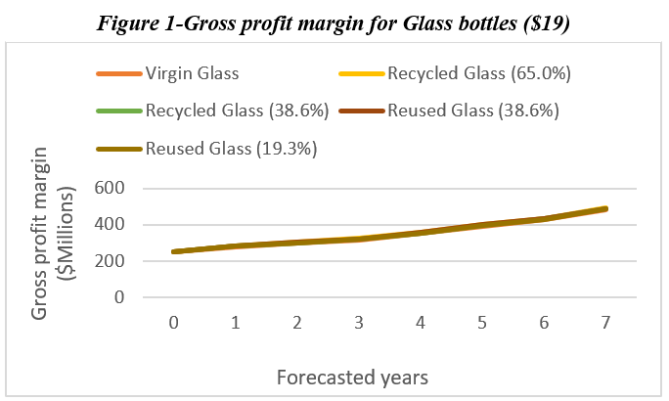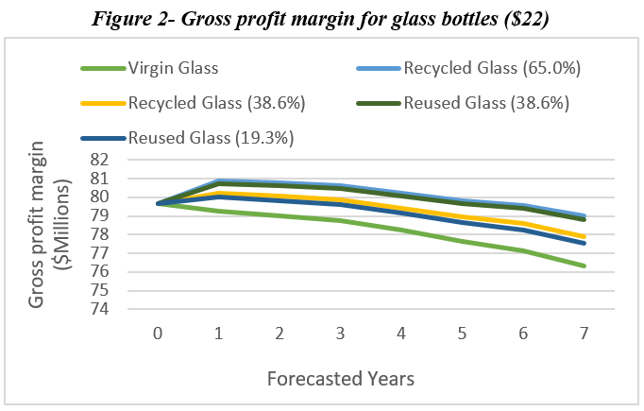

The gross profit margin for aluminum cans priced at both $19 and $17 per 12 pack show a stable growth into the forecasted years. The GPM for aluminum cans at both $17 and $19 appears to have approximately doubled by the end of year 8 (Figure 3).

### 

### 

### 

### 

### *Net Present Value of Gross Profit Margin by Alternative*

As a next step, we discounted the gross profit margin of each packaging alternative to the present time using the discount rate of 8.68%. From Figure 4 below, it can be inferred that the hard seltzer alternative with the highest net present value of its gross profit margin is the hard seltzer in an aluminum can priced at $17, with a present-value gross profit margin of approximately *$8 Billion*. On the other hand wherein glass bottles are used, it can be concluded that recycled glass packaging at 65% and 38.6% recovery rates and both reused glass alternatives achieve the maximum profit with a net worth of approximately *$4.2 Billion*, when priced at $19. We used this information in combination with the aggregate CO2 emissions calculations discussed earlier to build a multi-attribute utility model and an efficient frontier plot of profitability and sustainability utility.

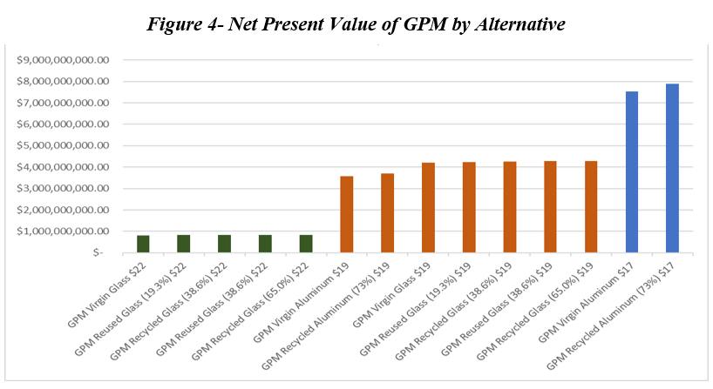

### *Multi-Attribute Utility Model and Efficiency Frontier Plot*

Provided that there is a net present gross profit margin value and aggregate CO2 emissions value for each of the 14 hard seltzer alternatives, we applied proportional utility scoring techniques to extract utility scores for both profitability (wherein a high net present GPM yields high utility) and sustainability (wherein low aggregate CO2 emissions yields high utility). With the proportional utility scores for profitability and sustainability calculated for each alternative, we created collectively exhaustive utility weights initially at values of 0.50 each, i.e., evenly prioritizing profitability and sustainability, and calculated the total weighted utility per hard seltzer, and rank-ordered them from greatest to least total weighted utility (Appendix II). With even utility weights, the multi-attribute decision making model suggests that Alternative 14, using recycled aluminum cans to package and market hard seltzers at $17, yields the greatest total weighted utility relative to the remaining hard seltzer alternatives (refer to Appendix II for an Alternative Key).

***Table 11: Multi-Attribute Utility Model with Equal Profitability and Sustainability Weights***

| **Alternative** | **Total Weighted Utility** | **Utility Rank (Highest-Lowest)** |
| --- | --- | --- |
| 1 | 0.6507613233 | 6 |
| 2 | 0.6764044452 | 3 |
| 3 | 0.6659893926 | 5 |
| 4 | 0.690931898 | 2 |
| 5 | 0.671116143 | 4 |
| 6 | 0.4907675846 | 13 |
| 7 | 0.4975888449 | 9 |
| 8 | 0.4948183638 | 12 |
| 9 | 0.5014567112 | 8 |
| 10 | 0.4961839024 | 10 |
| 11 | 0.4949566376 | 11 |
| 12 | 0.5963938818 | 7 |
| 13 | 0.4747141672 | 14 |
| 14 | 0.7153437768 | 1 |
| **Utility Weights** | **Profitability (Gross Profit Margin)** | **Sustainability (Aggregate CO2 Emissions)** |
|  | 0.50 | 0.50 |

However, changes in utility weights by definition will cause a change in the output of the multi-attribute utility model, which is best illustrated by plotting the profitability and sustainability utility scores per alternative on a scatter plot, which forms a profitability-sustainability efficient frontier plot (Figure 5). As shown in the efficient frontier plot below in Figure 5, Hard Seltzer Alternatives 9 , 4, and 14 form the efficient frontier between utility for profitability and sustainability. This indicates that Alternative 9 ($22 Glass Bottle with 38.6% Reused Glass) is the optimal alternative for maximizing sustainability (minimizing carbon footprint), Alternative 4 ($19 Glass Bottle with 38.6% Reused Glass) is the optimal alternative for marginally prioritizing sustainability over profitability, and Alternative 14 ($17 Aluminum Can with 73% recycled material) is the optimal alternative for marginally-to-totally favoring profitability over sustainability. Alternatives displayed in the efficient frontier plot below, such as 11, 12, and 13, as well as the remaining alternatives clustered behind the alternatives displayed, fall below the efficient frontier, indicating that they will always be inferior to those on the efficient frontier so long as the goal is to balance maximizing both sustainability and profitability (Figure 5). This assessment is consistent with the sensitivity analysis of the multi-attribute utility model: when the utility weight for profitability is between 0 and 0.18 (i.e., when sustainability is between 0.82 and 1), the alternative that achieves maximum total weighted utility is Alternative 9; when it is between 0.19 and 0.47, Alternative 4 is the alternative that achieves maximum total weighted utility; and when it is between 0.48 and 1, Alternative 14 is the alternative that achieves maximum total weighted utility.

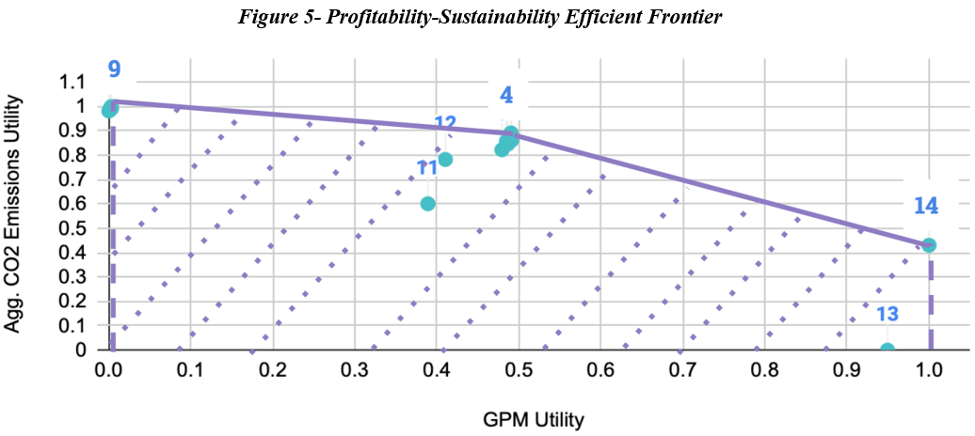

# **Discussion**

## Implications of Findings, Limitations and Future Research

Provided the results showcased in the previous section, it would seem that Hard Seltzer Alternative 14 – $17 Aluminum Can with 73% recycled material – is the evident choice, as even with equally prioritizing profitability and sustainability yielded Alternative 14 as the optimal alternative. However, there is still great value in the remaining alternatives, especially if such alternatives are viable for hard seltzer companies. For example, currently, zero of the top 30 12-pack hard seltzer products are listed at prices below $17.99 on Drizly – what if pricing a 12-pack of hard seltzers in Drizly’s online marketplace at $17 is financially infeasible? Per the multi-attribute utility model and efficient frontier, the next-most optimal alternative in terms is Alternative 4 – $19 Glass Bottle with 38.6% Reused Glass – which is significant because it implies that what is arguably the most sustainable program (implementing a circular economic program) also has the potential to be the most profitable alternative. Effectively, we can argue that – to a certain extent – increased sustainability necessarily leads to increased profitability. While this project does not account for the costs of collecting and cleaning processes to fully execute a circular economic program, it behooves future researchers to further verify such an argument.

*Transportation & Distribution Cost & Logistics*

From the research conducted in this project, limitations surrounding the overall process of creating a new hard seltzer product arose. As our interviewees emphasized, distribution and transportation of any product comes with logistic planning and additional costs. When looking at the transportation process of the product, an initial step would be to find the truck load capacity by weight, which would determine how many units are transported at once. These findings would then be used to model total transportation cost and emissions output per alternative and analyze their effect on overall profitability-sustainability tradeoff.

### *Investor Relations*

A critical aspect when thinking about developing a product and creating a company around said product is to find investors willing to invest in that idea. The forecasts shown above will show how the creator expects the product to perform in its market, but further work is required to get investors to pour their money into it. Not only does the product need to be profitable; investors need to know that their initial investment will increase in value, so in the case where it is acquired by another company or the company goes public, they will be able to make a significant capital gain from that investment.

To convince investors, the creator of the product needs to show enough proof that the forecasts and estimates are adequate. However, he must find additional ways of motivating funders. A growing trend in today’s market is investing in ESG. Environmental, Social, and Governance (ESG) is attracting more investors. A report recently released by the ERM’s Sustainability Institute[16](https://www.sustainability.com/thinking/2022-sustainability-trends-report/) noted that one in every three dollars of global assets under management is already invested in a fund or strategy that in some way integrates ESG considerations. As companies try to move towards sustainable targets, investors feel the urge to be proactive and invest in those companies that are making the most progress towards those goals. While our project shows the considerations of CO2 emissions and compares the difference in emissions between materials, if a real product and company were to be created, it would be essential to find strategies that increase the company’s ESG ratings so that more investors feel more encouraged to support the company.

# **Conclusion**

From our research, we deduced that glass bottles provide long-term sustainability benefits relative to aluminum cans. The variations in production cost and emission flows stems from the product’s selling price that appeared to drive product market share. Additionally, marginal market share benefits (e.g. glass bottle packaging) create significant long-term differences in profitability. And thus, we see a potential for circular economic programs to deliver significant advantages in both profitability and sustainability, if implemented.

# 

# **References**

1. “What Is Hard Seltzer? The Truth About This Fizzy Fad.” *Usual wines*, 6 May 2021, https://usualwines.com/blogs/knowledge-base/what-is-hard-seltzer.
2. “Hard Seltzer Market Size & Share Report, 2022-2030.” *Grand View Research*, https://www.grandviewresearch.com/industry-analysis/hard-seltzer-market.
3. Lane, Christian, et al. *AMC Seltzer Final Analysis Report*. Revolutionizing the Hard Seltzer Surge. 12 December 2021. *SEAS GWU*, https://madd.seas.gwu.edu/showcase/2021-Fall/seltzer.html.
4. *Drizly: Your Online Liquor Store - Buy Beer, Wine & Liquor*, https://drizly.com.
5. “Hard Seltzer Market Size & Share Report, 2022-2030.” *Grand View Research*, https://www.grandviewresearch.com/industry-analysis/hard-seltzer-market.
6. *Understanding the LOHAS Market Report*, https://www.lohas.se/wp-content/uploads/2015/07/Understanding-the-LOHAS-Consumer-11_LOHAS_Whole_Foods_Version.pdf.
7. *Aluminum facts*, 22 February 2022, https://www.nrcan.gc.ca/our-natural-resources/minerals-mining/minerals-metals-facts/aluminum-facts/20510.
8. Gitlitz, Jenny. “Container Recycling Institute.” *Container Recycling Institute*, https://www.container-recycling.org/images/stories/PDF/BottledUp-BCR2000-2010.pdf.
9. Gaines, L., and M. Mintz. “Energy Implications of Glass-Container Recycling.” *NREL*, https://www.nrel.gov/docs/legosti/old/5703.pdf.
10. Souder, J., et al. “Assessing the Circular Potential of Beverage Containers in the United States.” *Can Manufacturers Institute*, https://www.cancentral.com/sites/cancentral.com/files/public-documents/Metabolic_Report_RecyclingUnpacked.pdf.
11. Documentation for Greenhouse Gas Emission and Energy Factors Used in the Waste Reduction Model (WARM) by ICF International For the U.S. Environmental Protection Agency Office of Resource Conservation and Recovery   
    https://www.epa.gov/sites/default/files/2016-03/documents/warm_v14_containers_packaging_non-durable_goods_materials.pdf.
12. Beverage Container Recycling Stagnates (2000-2010), U.S. Container Recycling Rates & Trends 2013 https://www.container-recycling.org/images/stories/PDF/BottledUp-BCR2000-2010.pdf.
13. Advancing Sustainable Materials Management: 2018 Tables and Figures https://www.epa.gov/sites/default/files/2021-01/documents/2018_tables_and_figures_dec_2020_fnl_508.pdf.
14. Understanding the ™ LOHASMarket Report - By Natural marketing institute https://www.lohas.se/wp-content/uploads/2015/07/Understanding-the-LOHAS-Consumer-11_LOHAS_Whole_Foods_Version.pdf.
15. “Assessing the Circular Potential of Beverage Containers in the United States.” Can Manufacturers Institute, https://www.cancentral.com/sites/cancentral.com/files/public-documents/Metabolic_Report_RecyclingUnpacked.pdf.
16. “What's Next for Sustainable Business? 2022 Sustainability Trends Report.” The SustainAbility Institute by ERM, <https://www.sustainability.com/thinking/2022-sustainability-trends-report/>
17. Ecolabel index United states, <https://www.ecolabelindex.com/ecolabels/?st=country,us>
18. Global recycled standard, <https://cdn.scsglobalservices.com/files/program_documents/Global%20Recycled%20Standard%20-%20FINAL.pdf>
19. Glass container recycling loop, <https://www.gpi.org/glass-recycling-facts>
20. Top Glass Bottle Manufacturers and Suppliers in the USA, <https://www.thomasnet.com/articles/top-suppliers/glass-bottle-manufacturers-suppliers/>

# **Appendix**

**Appendix I: Equations used in calculations**

*Number of Packs Sold in Market (2021) = Market Size / Average Price per Pack of Product*

*Packs Sold of Product i = Product i Market Share * Number of Packs Sold in Market (2021)*

*Revenue of Product i = Price of Product i * Packs Sold of Product i*

*Production Cost of Product i = Per-Container Production Cost * Packs Sold of Product i * 12 bottles/pack*

*Total Revenue of Brand j = ∑i (Revenue of Product i of Brand j}*

*Total Production Cost of Brand j = ∑i (Production Cost i of Brand j)*

*Gross Profit Margin (2021) of Brand j = Total Revenue of Brand j - Total Production Cost of Brand j*

*Emissions of Product i = Per-Container CO2 emissions * Packs Sold of Product i * 12 bottles/pack*

*Total Emissions of Brand j = ∑i (Emissions of Product i of Brand j)*

**Appendix II: Additional Information for Multi-Attribute Utility Model**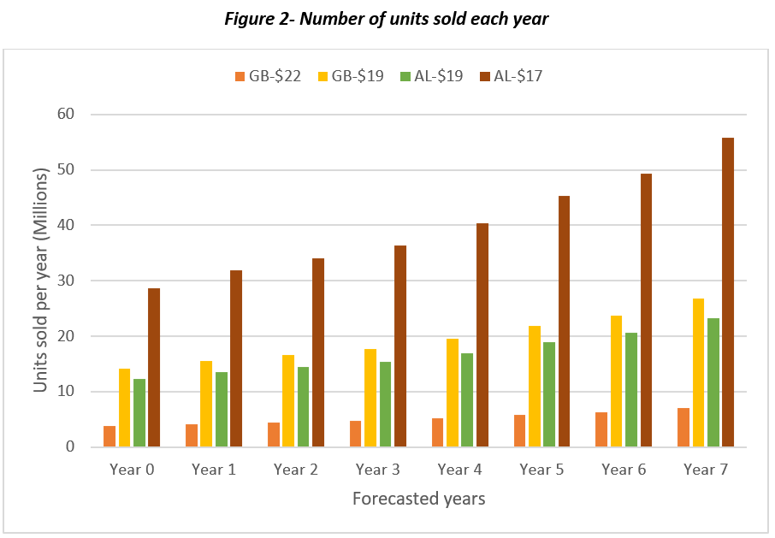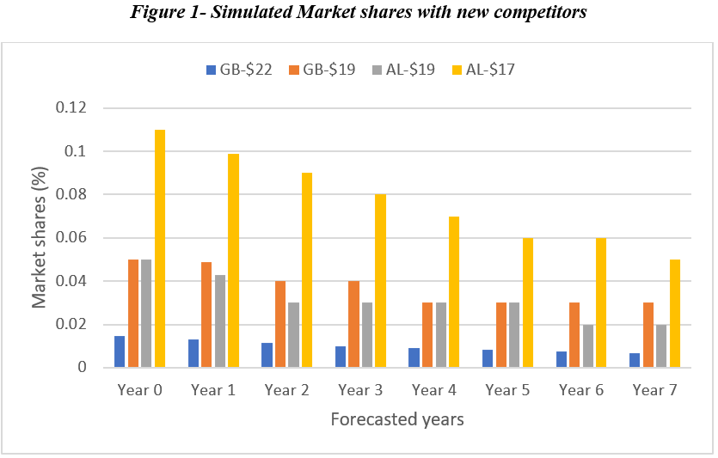

***Table 1: Multi-Attribute Utility Model Inputs with Proportional Utility Scoring***

| **Alternative** | **NPV (Gross Profit Margin Flows)** | **Aggregate CO2 Emissions** | **Gross Profit Margin Utility** | **Aggregate CO2 Emissions Utility** |
| --- | --- | --- | --- | --- |
| 1 | $4,202,241,550.57 | 530,906.59 | 0.4792701874 | 0.8222524592 |
| 2 | $4,285,778,267.74 | 434,357.43 | 0.4911020881 | 0.8617068023 |
| 3 | $4,251,849,508.77 | 473,571.24 | 0.4862965161 | 0.8456822691 |
| 4 | $4,279,774,003.20 | 361,175.76 | 0.4902516613 | 0.8916121346 |
| 5 | $4,241,007,776.89 | 444,722.02 | 0.4847609244 | 0.8574713617 |
| 6 | $818,452,346.64 | 141,124.11 | 0 | 0.9815351691 |
| 7 | $840,614,921.29 | 115,420.93 | 0.003139043441 | 0.9920386464 |
| 8 | $831,613,506.36 | 125,860.38 | 0.001864108874 | 0.9877726187 |
| 9 | $839,021,969.53 | 95,938.62 | 0.002913422327 | 1 |
| 10 | $828,737,158.08 | 118,180.18 | 0.001456711163 | 0.9909110936 |
| 11 | $3,564,808,172.00 | 1,072,513.78 | 0.3889859538 | 0.6009273213 |
| 12 | $3,714,733,285.73 | 628,021.69 | 0.4102209165 | 0.7825668471 |
| 13 | $7,521,697,056.49 | 2,543,049.67 | 0.9494283345 | 0 |
| 14 | $7,878,747,965.18 | 1,489,109.40 | 1 | 0.4306875536 |
| Best Value | $7,878,747,965.18 | 95,938.62 |  |  |
| Worst Value | $818,452,346.64 | 2,543,049.67 |  |  |

***Table 2: Alternative Key for Multi-Attribute Utility Model***

| Alternative Key | |
| --- | --- |
| 1 | Virgin Glass $19 |
| 2 | Recycled Glass (65.0%) $19 |
| 3 | Recycled Glass (38.6%) $19 |
| 4 | Reused Glass (38.6%) $19 |
| 5 | Reused Glass (19.3%) $19 |
| 6 | Virgin Glass $22 |
| 7 | Recycled Glass (65.0%) $22 |
| 8 | Recycled Glass (38.6%) $22 |
| 9 | Reused Glass (38.6%) $22 |
| 10 | Reused Glass (19.3%) $22 |
| 11 | Virgin Aluminum $19 |
| 12 | Recycled Aluminum (73%) $19 |
| 13 | Virgin Aluminum $17 |
| 14 | Recycled Aluminum (73%) $17 |

